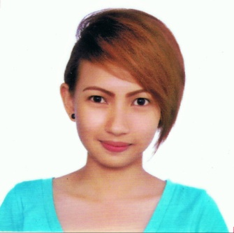

**MELISSA FAYE SEGISMAR VILLALUZ**

1109-A Poblacion Ward 4,

Minglanilla, Cebu, Philippines 6000

Cell No.: +639435605323

E-mail Address: melville1025@gmail.com

**Career Objective:** To succeed in an environment of growth and excellence which provides me job satisfaction and self-development and help me achieve personal as well as organizational goals.

**A. PERSONAL**

Age: 21 Gender: Female

Birthday: October 25, 1993 Birthplace: Minglanilla, Cebu

Height: 150 cm Citizenship: Filipino

Weight: 80 lbs. Person to contact in case of

Marital Status: Single emergency: Liezl S. Villaluz

Religion: Roman Catholic (+639279686543)

**B. EDUCATIONAL**

Tertiary : Bachelor of Laws

South Western University

Villa Aznar, Urgello St., Cebu City

October 2014-Present

BS in Information and Communications Technology

University of San Carlos - Technological Center

Nasipit, Talamban, Cebu City

June 2010 – March 2014 (Graduated)

Secondary : St. Cecilia’s College Cebu

Poblacion Ward II, Minglanilla, Cebu

June 2008-2010

University of the Visayas – Minglanilla Campus

Poblacion Ward I, Minglanilla, Cebu

June 2006-2008

Elementary : Minglanilla Central School

Poblacion Ward I, Minglanilla, Cebu

April 2006

**C. SKILLS**

* Basic knowledge in C Programming Language
* Basic knowledge in Web Applications ( HTML, CSS, PHP, mySQL)
* Has basic Computer Technician Skills
* Knowledgable in Software Applications ( Adobe Photoshop, Sony Vegas and Corel Draw)
* Proficient in MS Applications (Word, Excel and Powerpoint)
* Proficient in both oral and written English
* Committed to the work or task given
* Honest and Trustworthy
* Can work with less supervision
* Organized and Detail Oriented

**D. COMPLETED PROJECT/S**

* Undergraduate Capstone Project:

TITLE: Mandaue City Police Office Record Management System (March 2014)

* Undergraduate Research for Partial Fulfillment of the Subject College Composition and the Research Paper:

TITLE: Privacy Features of Social Networks for Services (January 2013)

* Undergraduate Feasibility Study for Partial Fulfillment of Presentation Skills in Information Technology:

TITLE: A Feasibility study on putting up a Mini Library Research Center on the Lawrence Bunzel Building and Philip Van Engelen Building of the University of San Carlos – Talamban Campus (September 2012)

**E. WORK EXPERIENCE**

* Data Analyst at Accenture Inc. (April 2014 – October 2014)
* Editorial Coordinator Assistant (OJT) at Philippine Daily Inquirer Visayas (July 2013- December 2013)

**F. CHARACTER REFERENCES**

**Ronilo S. Olivar, Jr.** **Grace Zabala- Oberes**

Laboratories Head/ Faculty Member Editorial Coordinator

Department of Computer Science Philippine Daily Inquirer- Visayas

University of San Carlos gracee_zabs@yahoo.com

09229373088 / 2300 100 156

ron.olivar@gmail.com

*Resume of Melissa Faye Segismar Villaluz...p.2*

*I hereby certify that the above information is true and correct to the best of my knowledge and belief.*